**Do you have a child aged 18 months to 10 years?**

**Would you like them to sleep all night?**

**In their own bed?**

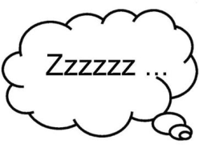

**Without calling out or coming downstairs?**

**Worried your child doesn’t sleep for long enough?**

**Night Mares or Night Terrors?**

***Come to our short workshop about* any difficulties you may be facing with sleep.**

MC900129380[1]

**Wednesday 13th April**

**12:30-2:30pm**

Netherton Park Children’s Centre

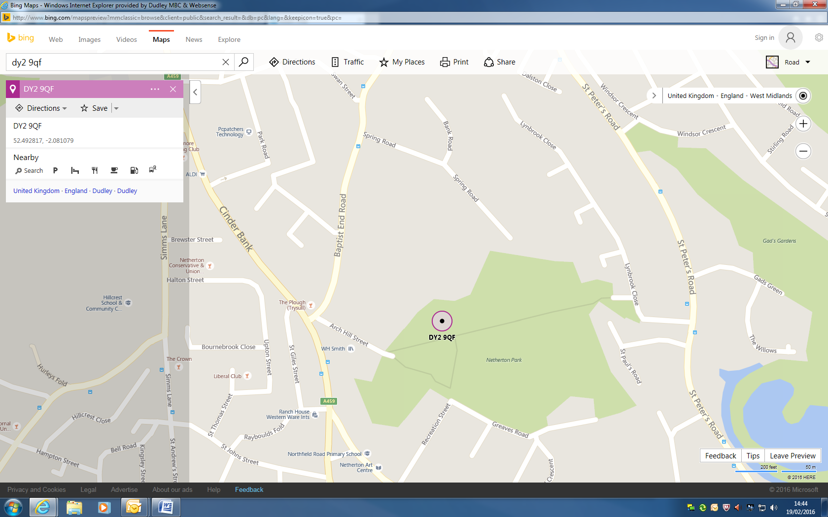

**Netherton Park Children’s Centre**

**Dudley**

**DY2 9QF**