**Do you have a child aged 18 months to 10 years?**

**Would you like them to sleep all night?**

**In their own bed?**



**Without calling out or coming downstairs?**

**Worried your child doesn’t sleep for long enough?**

**Night Mares or Night Terrors?**

***Come to our short workshop about* any difficulties you may be facing with sleep.**

MC900129380[1]

**Wednesday 16th March**

**5:45-7:45pm**

Kates Hill and Sledmere Children’s Centre

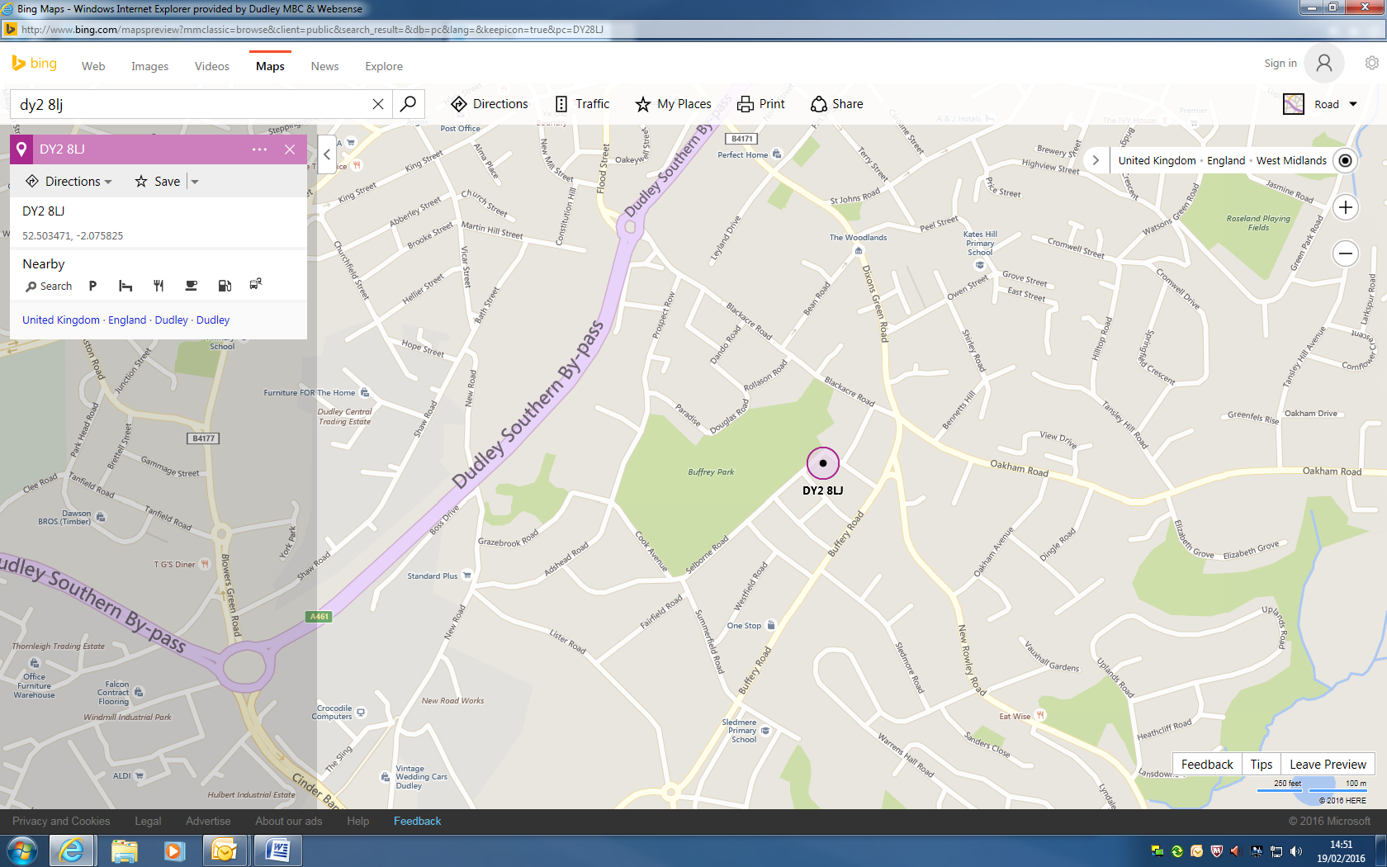

**Kateshill and Sledmere Children’s Centre**

**Dudley**

**DY2 8LJ**